Software Page

What is ExceedenceFinance Software?
ExceedenceFinance is a software that provides a calculation tool combine with a set of renewable resource data and other criteria that will allow the user to calculate efficiently and rapidly the financial outcomes of their products and projects in WIND, WAVE, TIDAL and combined platforms.
- Cashflows
- LCOE
- IRR
- NPV
- NPV/MW of Renewable Energy Project.
This quick calculation enables the users to free time for scenario building and a robust cost-benefit analysis of each project.
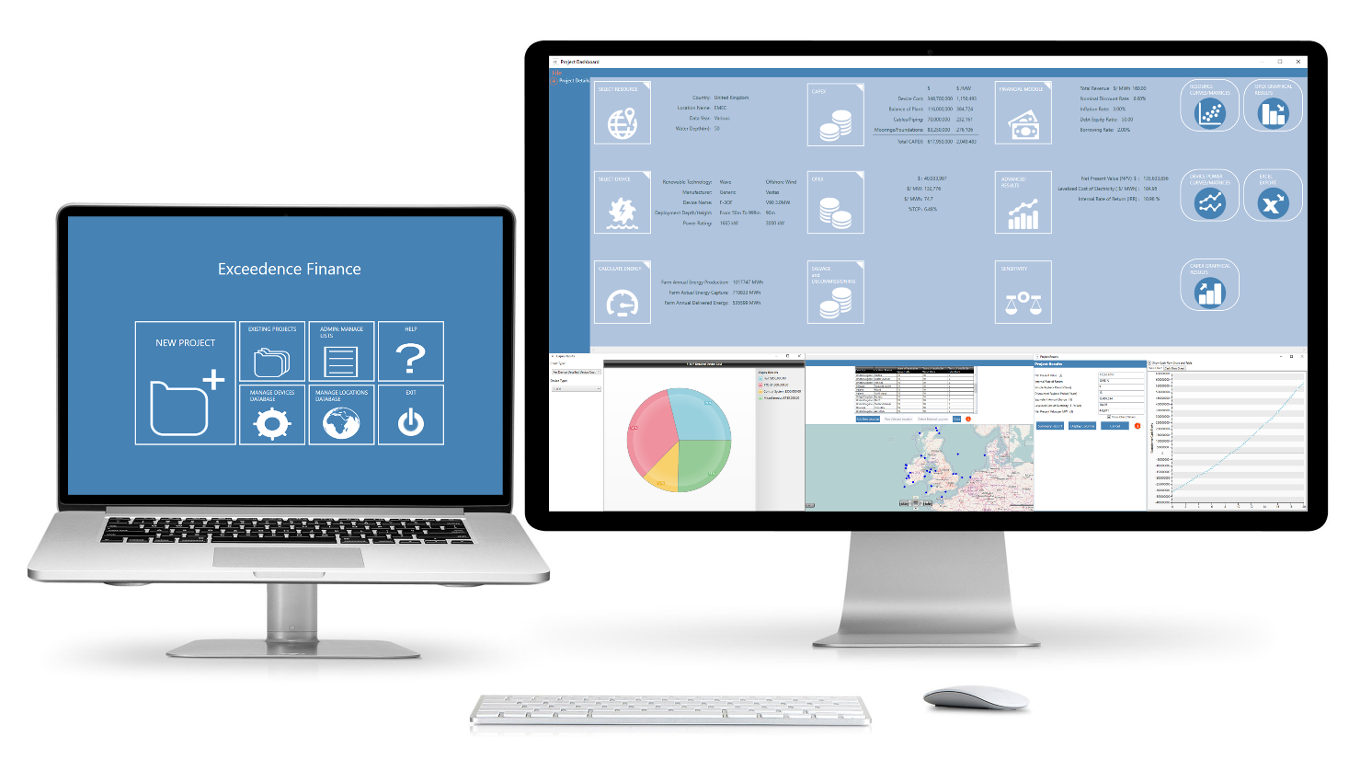

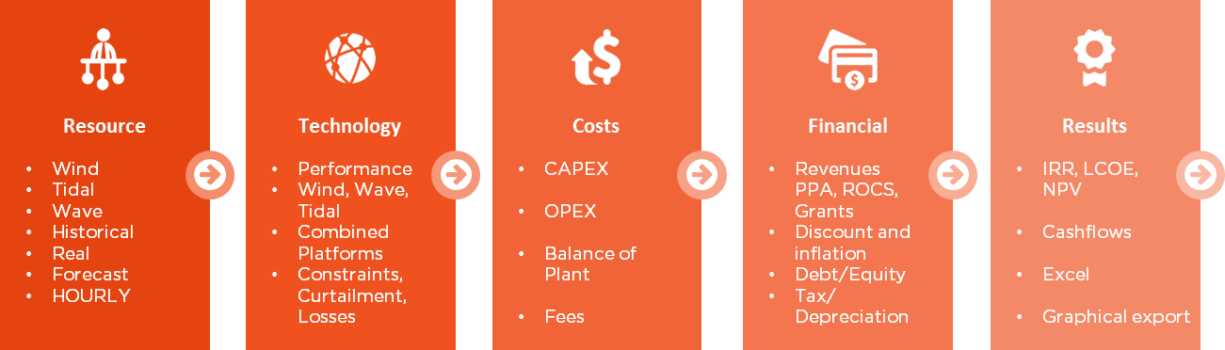

Who can use the software?
As the software combines the use of technical data to calculate the financial outcome of a project, the software can be used across the supply chain.

Device Developer:
A developer of technology will find our software useful to help them decide on their technology development pathway. Indeed, the analysis provided by the software can show the better path of exploitation based on the cost of energy depending on the materials used, PTO, components the size of their project and the location. That could lead device developer on a cost reduction trajectory and also increase their TRL. We have also helped developers prove that their technology is superior to a competitors when benchmarked in a real project.
We have helped and are still helping device developers make informed decisions on their Levelised Costs by changing their Power take off system, O&M, moorings and deployment of their technology.
Our software has also, in the past, been useful for device developers to secure funding by demonstrating the result of their choice on their financial outcomes. As the software allows the standardisation of the information, the results provides by the software can be useful for reporting to third parties and have their confidence in the numbers. We have been doing this in a number of Wave Energy Scotland projects with PTO systems and materials. See http://exceedence.com/exceedence-awarded-495k-wave-energy-scotland-stage-2-pto-funding/
Project developer:
By using our software, a project developer can decide on the right parameters in relation to his project to get the better cost/benefit. They can also compare different scenarios and decide the one that has the best IRR. Using the sensitivity tools will help create optimised projects.
The software allows project manager to free their time from lengthy and costly builds in spreadsheet software. Our software allows the reallocation of engineering resource from the build/audit phase of the financial model to the analysis part and gives a common platform to a team so that they can work more efficiently. See http://exceedence.com/workshop-on-techno-finance-yields-surprising-results1/ One customer saved 1200 man hours in 3 months.
The standardisation of the reporting will allow a better understanding in the team, the management and importantly outside the organisation to funder and financiers.
Supply chain:
Across the supply chain our tool provides a common language and metrics to talk and sell more efficiently to the right stakeholders. For example, we have we have shown that the selection of certain critical components can reduce LCOE by almost 50%. This analysis can be done for O&M operators, installation, Balance of Plat and any other product/service along the supply chain.
Consultants:
Consultants will find our software helpful for their business. The combination between a specific set of data and the financial tool in the software will ensure the delivery of the results accurately and quickly. You will be able to spend your time adding significantly more value to your client, using standardised software and being more competitive in the market place.
Investors/Funders:
Funders and investors can rely on the numbers delivered by our software to make informed decision on the funding or acquisition of projects. The software report haves the same language used in the financial sectors and presents the numbers that matter to you. You can compare projects on a fully like for like basis, regardless of scale or location. Our currency tool allows you to check FOREX scenarios and the project sensitivity allows you to run a range of what-if analysis.
Utility agency:
The utility can use our software to decide on the way that they will make the grid react to the technology to give the better access to the energy. By assessing the financial outcomes of Renewable energy project, they can project their own finances and therefore choose on the better adaption and price for the access to the grid for a win-win situation. For example they can look at PPAs or strike prices and fully understand margins. They can also understand the financial effects of curtailment and constraint on either their own projects or those of customers.
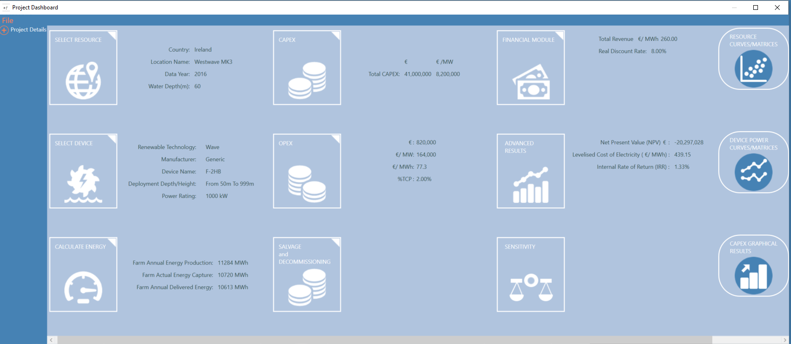
Main Features:
- Homepage: This is where the user can start a new project, open/edit existing projects, add/manage the database of devices and database of locations, manage lists of components in the project dashboard modules and also access the help menu.

- Project Dashboard: This allows the user to access all the modules required to build a project. The user is guided through the process and when complete the dashboard displays all the summary information about that project. ExceedenceFinance allows for wave, offshore wind, tidal farms to be modelled as well as combinations of these technologies in one farm.

- Resource Database: This contains a list of locations containing pre-populated resource data. The user can also add their location and resource data. Resource data can be entered as summary data or imported hourly time series from Excel or CSV files.
Examples of Resource Data
The following table lists the different resource data found during the ODINE project including links to the websites.
Energy Source | Country | Organisation/Name | Open Source (Y/N) | URL | Data Sets
Wind/Wave | UK | Environmental Agency | Y | http://wavenet.cefas.co.uk/Map  This Data set is OPEN DATA provided by Gardline Environmental on behalf of the Environmental Agency and is available to download from the WaveNet website for use under Open Government License. Accessed through Cefas WaveNet interactive map  at http://wavenet.cefas.co.uk/Map | - Blakeney Overfalls  - Northwell
Wind/ Wave | USA | National Data Buoy Centre | Y | http://www.ndbc.noaa.gov/hmd.shtml  This is open data through the National Oceanic and Atmospheric Administration’s National Data Buoy Centre | - Kanehoe Bay Test site in Hawaii
Wind | NL | Nordzee wind | Y | http://www.noordzeewind.nl/en/knowledge/reportsdata/  This Data set is OPEN DATA from the Monitoring and Evaluation Programme (NSW-MEP) from the Egmund aan Zee Offshore Wind Farm. Accessed through http://www.noordzeewind.nl/en | - Nordzee Met Mast
Wave | IE | Marine Institute | Y | http://data.marine.ie/Dataset/Details/20973  This Data set is OPEN DATA from The Marine Institute of Ireland under the creative commons license. Accessed through Ireland’s Marine Atlas at erddap.marine.ie. Data set taken from RAW Te and HS values. Interpolation for missing data points. | - Belmullet A  - Belmullet B  - Galway Bay  - Westwave MK3  - M3 Buoy
Wind | UK | Crown Estate through Marine Data Exchange | Y | http://www.marinedataexchange.co.uk/ | - Gwynt Y Mor Met Mast
Tidal | IE | Exceedence | Awaiting response from UCC | www.exceedence.com  This Data set is OPEN DATA from UCC MAREI Current Prediction at Arklow Bank site. Licensed by Exceedence and made openly available. | - Arklow South
Wind | IE | Marine Institute | Y | http://data.marine.ie/Dataset/Details/20973  This Data set is OPEN DATA from The Marine Institute of Ireland under the creative commons license. Accessed through Ireland’s Marine Atlas at erddap.marine.ie. | - M2 and M3 Buoy

If your need specifics data to the cost calculation of your project, we can upload your set of data without additional cost into the software.

- Device Database: This contains a list of pre-populated devices that are actually on the market. If you require the implementation of a particular device that is not in the list, we can upload your device for you when acquiring the software.

For more
information
please contact:

Raymond Alcorn
Hydraulics & Maritime
Research Centre
Youngline Ind. Est.
Pouladuff Rd.
Cork
Ireland
r.alcorn@ucc.ier.alcorn@ucc.ie
+353-21-4250011
http://hmrc.ucc.ie

NAVITAS Structure and Features

- Energy Calculator: This calculates the energy output of the user’s farm. It allows for resource data to be adjusted where needed to match the user’s device deployment and also allows for losses factors such as transmission losses and losses due to availability to be accounted for.

- CAPEX: This allows to user to enter the Capital Expenses of the project. ExceedenceFinance allows CAPEX to be entered in three complexity levels ranging from the simplest where the user can enter one number to the most detailed where the user can customise a list of items for each area of the project and enter individual costs for each item.

- OPEX: This allows to user to enter the Operational Expenses of the project. ExceedenceFinance allows OPEX to be entered in three complexity levels ranging from the simplest where the user can enter one number to the most detailed where the user can customise a list of items for each area of the project and enter individual costs in each year for each item. OPEX costs can be entered as fixed or variable.

- Salvage and Decommissioning: This allows the user to enter any salvage value or decommissioning costs that may occur at the end of the project lifetime.

- Financial Module: This allows the user to calculate revenue that the project will earn, enter the discounting and inflation factors, input the debt/equity ratio and borrowing rate and also account for tax and assign any capital depreciation.

- Cash Flow Sheet: This gathers all the factors, cost and inputs from all the modules and generates the cash flows for the project from which the projects results are produced.

- Project Results: This outputs the projects financial results in terms of Net Present Value, Internal Rate of Return, Simple and Discounted Payback Period and Levelised Cost of Electricity.

- Recommended Values: Each screen in ExceedenceFinance contains an information button. This contains an information sheet for describing all the factors on that screen. It also contains up to date typical industry values for any input values. These industry values have been researched and references and represent state of the art industry figures and Beaufort Research’s unique expertise in this area.

- Sensitivity: This allows the user to compare different projects, adjust inputs within a project to view the impact on the results, perform ‘goal seek’ on any input factor in a project and also perform sensitivity on the project comparing results for a range of major inputs.

Examples of results:
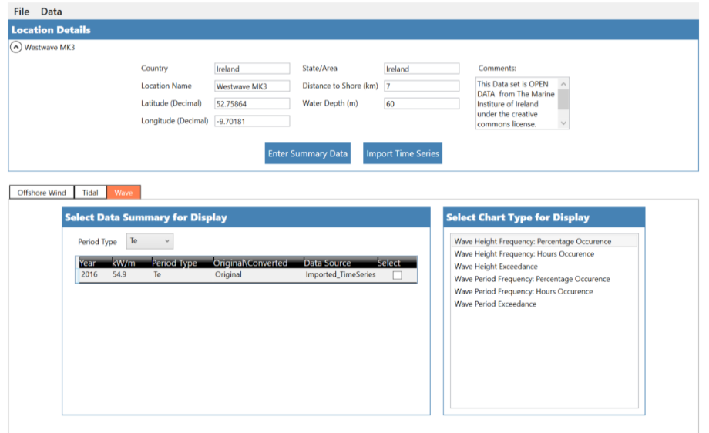
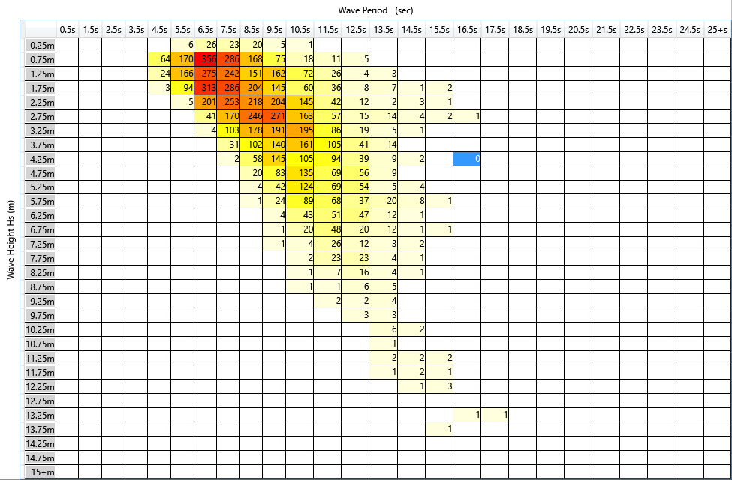

The following figures show some graphical outputs from the software in terms of IRR, NPV and LCOE. In these following examples, you can see how we can evaluate the viability of a project and how we can decide of the better idea for a project.
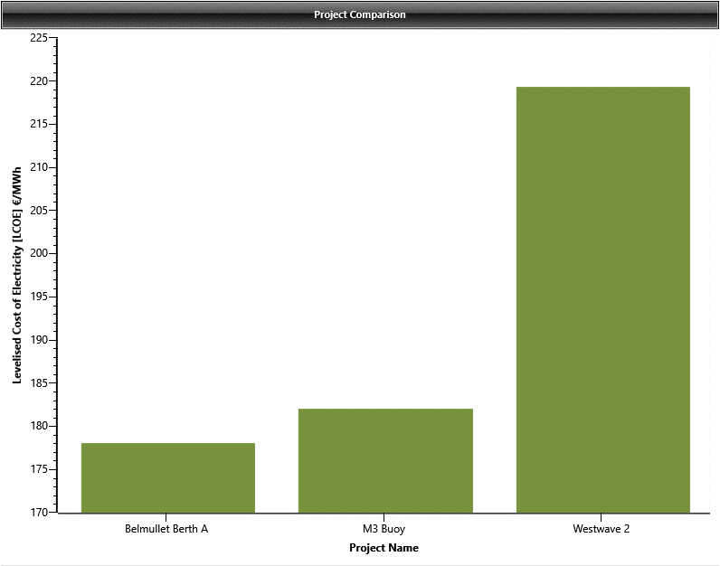 | 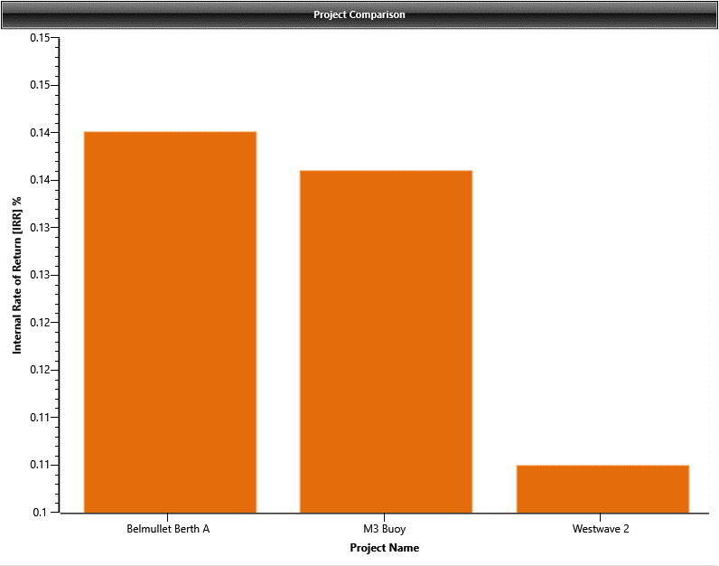 | 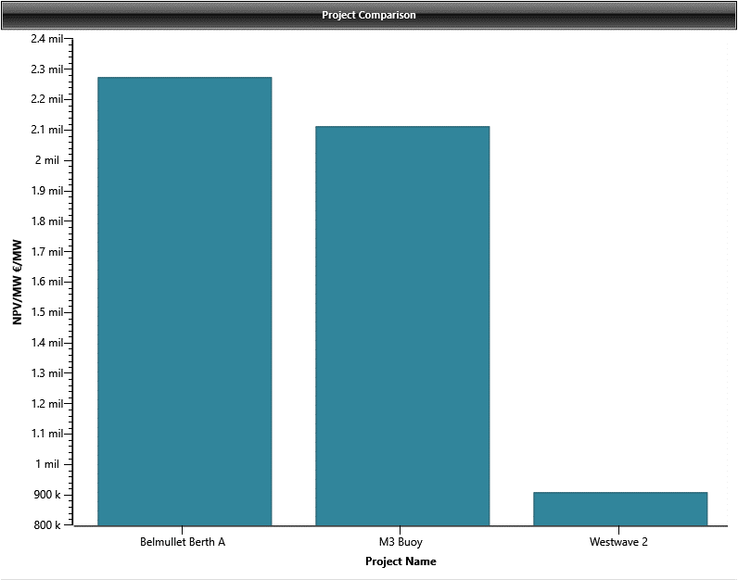

How to acquire the software?
We can offer you for a trial period of one month that will allow you to use the principal features of the software for this period. Go to the CONTACT page http://exceedence.com/contact-us/ and complete the form. We will provide support during this trial period. Following this trial period, you can acquire the full version and we will make sure that all your previous work on the evaluation licence will be uploaded on the final version.

Requirements for the user
- Minimum Specification: 4 GB RAM, Processor: i5 or similar.
- Recommended Specification: 8 GB RAM
- Free space prior to installation: 500 MB
- Software:
  - Windows 7 or later (Windows XP is not supported). Not supported on Apple or Linux.
  - Excel or similar (to read Excel Export files)
  - Adobe PDF Reader or similar (to read help and project summary files)

